**Metric report cheatsheet**

**Introduction**

The workspace feature in Microsoft Power BI is a vital collaborative tool that allows teams to access data easily and work effectively. A **Usage metric report** is crucial for understanding how individuals interact with the reports and dashboards in the workspace.

The **Usage metric report** simplifies each metric for easy understanding and swift application, enabling you to gauge report interactions and user engagement, effectively facilitating more informed decision-making in optimizing your Power BI reports.

In this reading, you’ll explore the individual results and findings generated in the four pages of the report.

**Usage metrics report overview**

The updated **Usage metric report** is split into four different pages, which focus on different areas of performance results and metrics.

* **Report usage:** This page provides information about the number of report views and viewers. For example, it could display how many users viewed the report, broken down by date.
* **Report performance:** This report page collates the report opening times, broken down by consumption method and browser types.
* **Report list:** The **Report list** page shows a list of all active reports in a workspace, providing report usage tools across all contents.
* **FAQ:** This valuable information page answers frequently asked questions, such as “What is a viewer?” and “What is a view?”

Let’s explore the metrics provided in these individual pages in more detail.

**Report usage**

Understanding how your reports are accessed is crucial for evaluating their impact. The **Report usage** page provides metrics that help understand report accessibility and engagement.

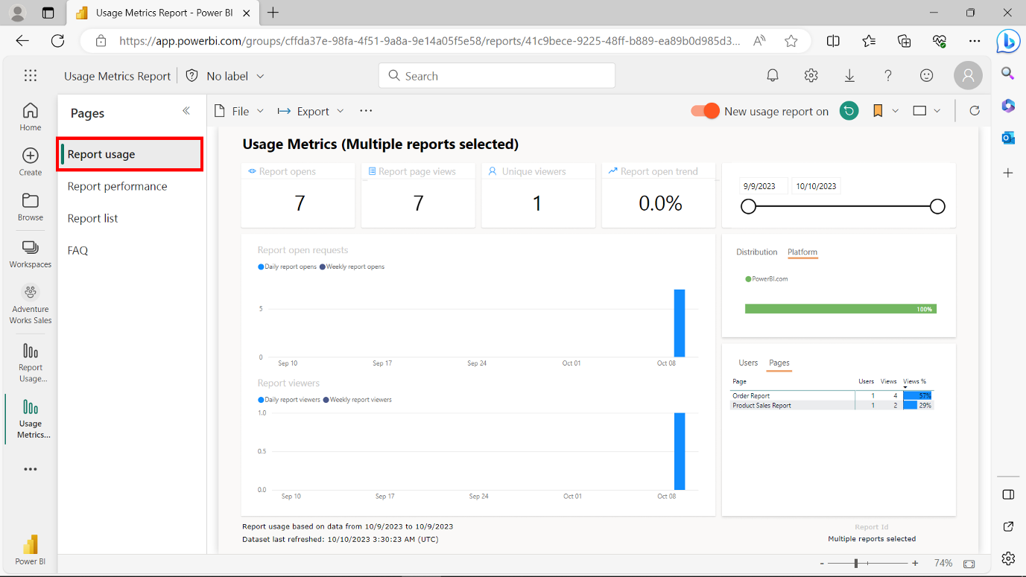

* **Report opens:** Each time a report is opened, a view is recorded. It represents unique landings on the report and shows how often the report has been accessed.
* **Report page views:** This metric counts views across all report pages and summarizes how often individual report pages are accessed.
* **Unique viewers:** This records individuals who opened the report at least once during a specified period.
* **Report open trend:** This metric demonstrates changes in view count over time and compares the first and second halves of the selected period.
* **Date slicer:** This slicer allows you to change the period specified on the **Report usage** page to refine the focus and to calculate trends such as week-over-week or biweekly.
* **Report viewers:** The visual shows the total number of users who viewed the report daily.
* **Distribution:** This item provides information on how users accessed the report. For example, through a workspace, a shared link, or an app installation.
* **Platform:** This indicates if the report was accessed via Power BI service, Power BI Embedded, or a mobile device.
* **Users:** This item lists users who opened the report, sorted by view count.
* **Pages:** This metric slices the report by the pages viewed for reports with multiple pages, capturing situations like page additions or deletions.

**Report performance**

The **Report performance** page provides insights into reports' efficiency and responsiveness, which helps optimize the user experience.

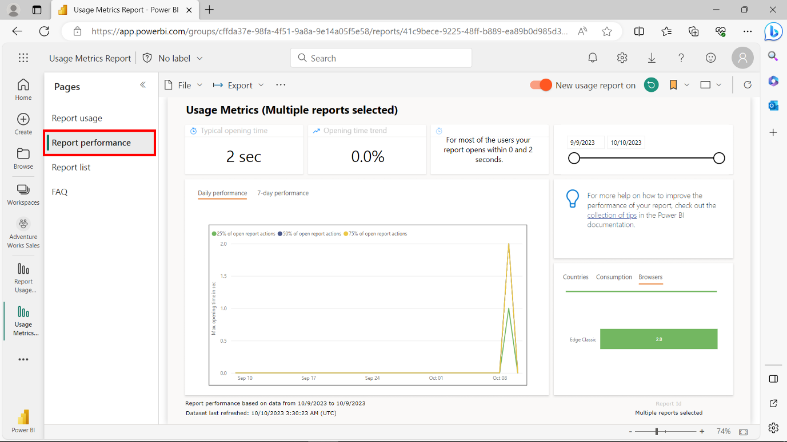

* **Typical opening time:** This reflects the median time it takes to open the report, which is useful for understanding performance benchmarks.
* **Opening time trend:** This metric analyzes changes in the report opening times over different periods, aiding in identifying performance trends.
* **Date slicer:** This slicer allows you to adjust the period specified to analyze performance trends weekly or biweekly.
* **Daily performance:** This metric shows the performance for 25%, 50%, and 75% of the open report actions for each day, providing a granular view of daily performance.
* **7-day performance:** This represents each date's performance across the previous seven days, offering a week-long performance view.
* **Consumption:** This indicates how users opened the report, whether via Power BI service, Power BI Embedded, or a mobile device.
* **Browsers:** This provides insights into the browsers used to open the report, such as Firefox, Edge, and Chrome, which could be crucial for ensuring cross-browser compatibility and performance.

**Report list**

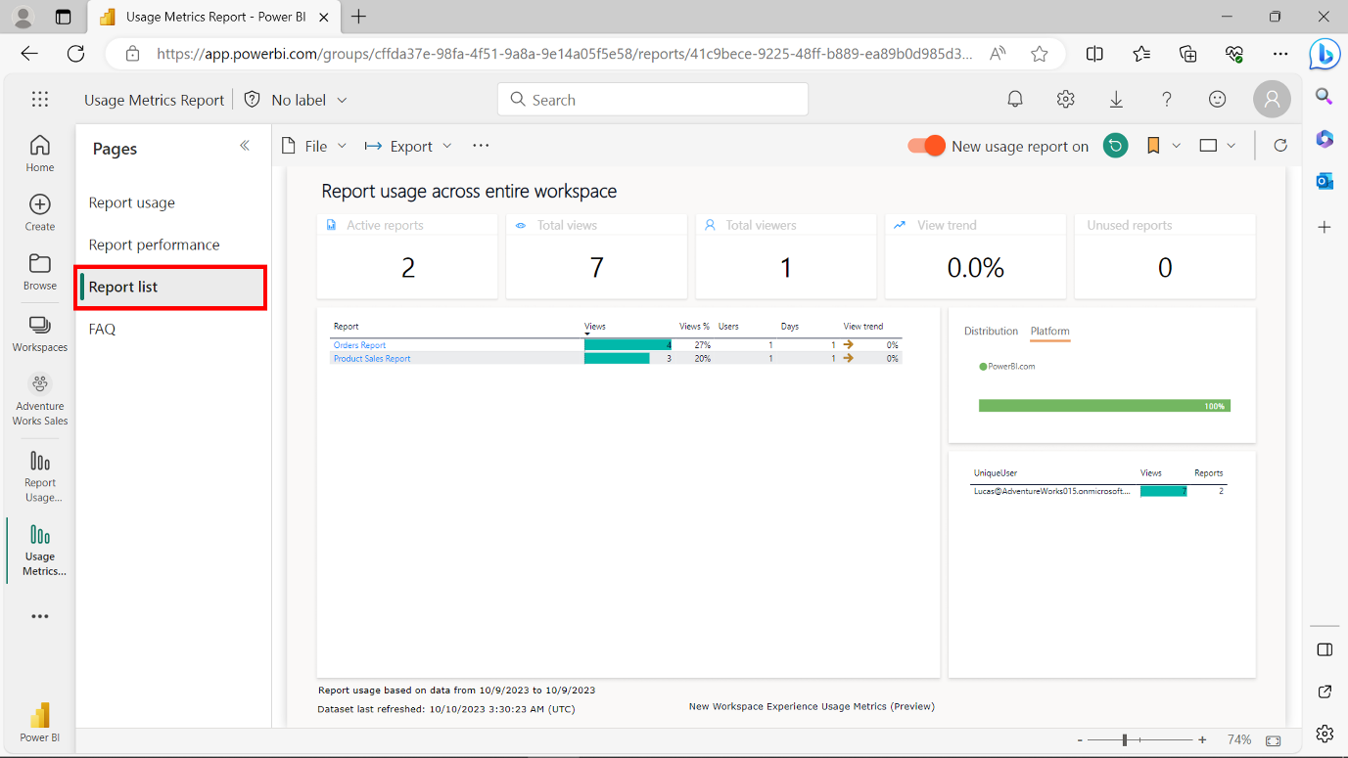

* **Active reports:** This metric identifies reports in use across the workspace.
* **Total views:** This metric aggregates the total number of reports across the workspace.
* **Total viewers:** This result summarizes the total number of viewers across the workspace.
* **Unused reports:** This metric counts the number of unopened or inactive reports over a specific period.
* **Table:** This table is visible in the middle of the page and is a **Report Usage** table. It summarizes contributions to the individual counts shown in cards, viewing trends, and interaction data.

**FAQ**

This page provides answers to frequently asked questions.

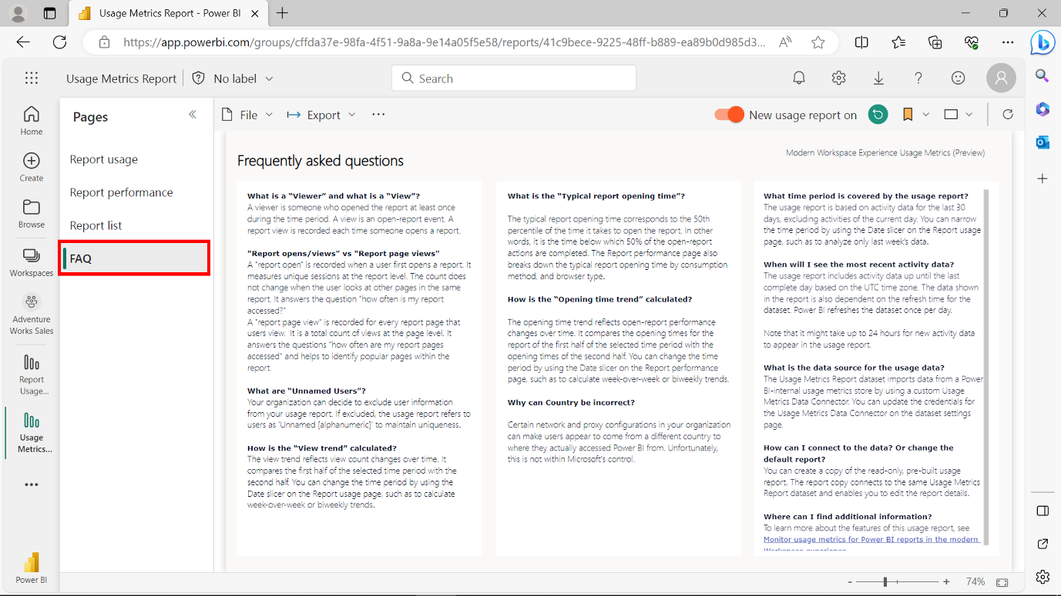

**Conclusion**

The updated **Usage metrics** feature in Power BI service is a powerhouse of insightful metrics spread across three informative pages: **Report usage**, **Report performance**, and **Report list**. Each page delves into different facets of report engagement, performance, or an overarching view across all reports. Monitoring these metrics allows you to gauge your reports' current standing and impact while helping you to make informed decisions to enhance future report engagement and performance.